## **Blood Gas Analysers:**

* Blood gas analysers are used to measure the pH, partial pressure of carbon dioxide (pCO2) and partial pressure of oxygen (pO2) of the body fluids with special reference to the human blood.
* The measurements of these parameters are essential to determine the acid-base balance in the body.
* A sudden change in the pH and pCO2 could result in cardiac arrhythmias, ventricular hypotension and even death.

## **Acid Base Balance:**

* The normal pH of the extracellular fluid lies in the range of 7.35 to

7.45, indicating that the body fluid is slightly alkaline.

* When the pH exceeds 7.45, the body is considered to be in a state of alkalosis. A body pH below 7.35 indicates acidosis
* Both alkosis and acidosis are disease conditions.
* Tendency of the pH of blood to deviate towards these conditions is dealt with by the following three physiological mechanisms:
* (i) buffering by chemical means, (ii) respiration, (iii) excretion into the urine by kidneys.
* H+= 0.00000004 eq/lit

**Buffering Chemical Means:**

* The blood and tissue fluids contain chemical buffers, which react with added acids and bases and minimize the resultant change in hydrogen ions. They respond to changes in carbon dioxide concentration in seconds.

**Respiration:**

* The respiratory system can adjust sudden changes in carbon dioxide tension back to normal levels in just a few minutes. Carbon dioxide can be removed by increased breathing and therefore, hydrogen concentration of the blood can be effectively modified.

**Excretion into urine:**

* The kidney requires many hours to re adjust hydrogen ion concentration by excreting highly acidic or alkaline urine to enable body conditions to return towards normal
* To maintain pO2, pCO2 and pH within normal limits, throughout the wide range of body activity, the rate and depth of respiration vary automatically with changes in the metabolism.
* Control of alveolar ventilation takes place by means of chemical as well as nervous mechanisms.
* The three important chemical factors regulating alveolar ventilation are the arterial concentrations of 𝐶𝑂2, 𝐻+ and 𝑂2.
* Carbon dioxide tension in the blood stream and cerebrospinal fluid is the major chemical factor regulating alveolar ventilation.
* The carotid and aortic chemoreceptors stimulate respiration when oxygen tension is abnormally low.

## **Blood PH Measurement**

* The acidity or alkalinity of a solution depends on its concentration of hydrogen ions.
* Increasing the concentration of hydrogen ions makes a solution more acidic, decreasing the concentration of hydrogen ions makes it more alkaline.
* The amount of hydrogen ions encountered in solutions of interest is extremely small and, therefore, the figure is usually represented in the more convenient system of pH notation.
* pH is thus a measure of hydrogen ion concentration, expressed logarithmically. Specifically pH = –log (𝐻+ )
* Electrochemical pH determination utilizes the difference in potential occurring between solutions of different pH separated by a special glass membrane.
* The pH of one of the solutions is kept constant, so that the potential varies in accordance with the pH of the other solution, then the system can be used to determine pH. The device used to effect this measurement is the glass electrode
* Glass Electrode: The potential (E) of the glass electrode may be written by means of the Nernst equation:

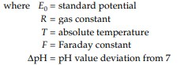

Change of pH of one unit = 58.2 mV at 20°C and

Change of pH of one unit = 62.2 mV at 40°C

**pH Measurement:**

* The solution is taken in a beaker. A pair of electrodes: one glass or indicating electrode and the other reference or calomel electrode, are immersed in the solution.
* The voltage developed across the electrodes is applied to an electronic amplifier, which transmits the amplified signal to the display.
* The pH meter is usually equipped with controls for calibration and temperature compensation.
* The glass electrode exhibits a high electrical resistance.
* The emf measurement, therefore, uses measuring circuits with high input impedance.
* The error caused in pH measurements due to temperature effect can be compensated either manually or automatically.
* In manual adjustment the instrument is calibrated at 25°C. Then the control is simply set to the actual measuring temperature.
* By this adjustment, the output current of the amplifier gets corrected to the desired temperature.
* In automatic adjustment, a variable resistor which is usually a thermistor or wire wound resistance that has an approximate desired resistance temperature coefficient is inserted in the circuit.
* During measurement, it is placed in the test solution. The use of an automatic temperature compensator will ensure that the pH meter is operating with a correct mV/pH conversion ratio

**Electrodes for Blood pH Measurement:**

* The electrodes available are of glass electrode type but made in different shapes so that they may accept small quantities of blood and yield accurate results.
* Typically, a micro-electrode for clinical applications requires only 20– 25μl of capillary blood for the determination of pH. The electrode is enclosed in a water jacket with circulating water at a constant temperature of 38°C.
* The water contains 1% NACl for shielding against static interference. The capillary is protected with a polyethylene tubing. The internal reference electrode is silver/silver chloride and the calomel reference electrode is connected to a small pool of saturated KCl, through a porous pin.
* An accuracy of 0.001 pH can be obtained with this electrode against a constant buffer.

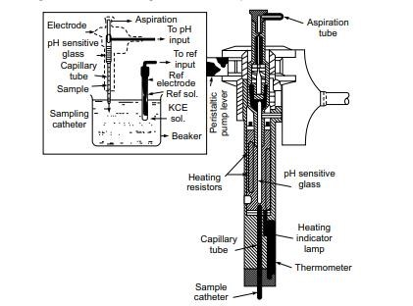

Microcapillary electrode for measurement of blood pH

## **Measurement of Blood PCO2:**

* The blood pCO2 is the partial pressure of carbon dioxide of blood taken anaerobically. It is expressed in mmHg and is related to the percentage CO2 as follows:
* All modern blood gas analysers make use of a pCO2 electrode.
* It basically consists of a pH sensitive glass electrode having a rubber membrane stretched over it, with a thin layer of water separating the membrane from the electrode surface.
* The technique is based on the fact that the dissolved CO2 changes the pH of an aqueous solution.
* The CO2 from the blood sample diffuses through the membrane to form 𝐻2𝐶𝑂3, which dissociates into (𝐻+) and (𝐻𝐶𝑂3−) ions.
* The resultant change in pH is thus a function of the CO2 concentration in the sample.
* The emf generated was found to give a linear relationship between the pH and the negative logarithm of pCO2.

## **Blood PO2 Measurement:**

* The partial pressure of oxygen in the blood or plasma indicates the extent of oxygen exchange between the lungs and the blood, and normally, the ability of the blood to adequately perfuse the body tissues with oxygen.
* The partial pressure of oxygen is usually measured with a polarographic electrode. There is a characteristic polarizing voltage at which any element in solution is predominantly reduced and in the case of oxygen, it is 0.6 to 0.9 V.
* In this voltage range, it is observed that the current flowing in the electrochemical cell is proportional to the oxygen concentration in the solution.
* Modern blood gas analysers utilize an oxygen electrode for measuring oxygen partial pressure.
* This type of electrode consists of a platinum cathode, a silver/silver chloride anode in an electrolyte filling solution and a polypropylene membrane.
* The electrode is of a single unit construction and contains the reference electrode also in its assembly.
* The entire unit is separated from the solution under measurement by the polypropylene membrane.
* Oxygen from the blood diffuses across the membrane into the electrolyte filling solution and is reduced at the cathode.
* The circuit is completed at the anode, where silver is oxidized, and the magnitude of the resulting current indicates the partial pressure of oxygen.
* The reactions occurring at the anode and cathode are:

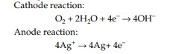

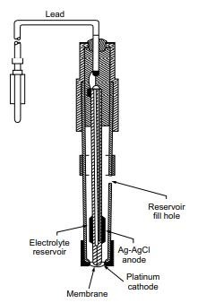

Constructional details of pO2 electrode

**The principal advantages are:**

* (i) sample size required for the measurement can be extremely small,
* (ii) the current produced due to pO2 at the electrode is linearly related to the partial pressure of oxygen,
* (iii) the electrode can be made small enough to measure oxygen concentration in highly localized areas,

(iv) the response time is very low, so the measurements can be made in seconds